1. Home

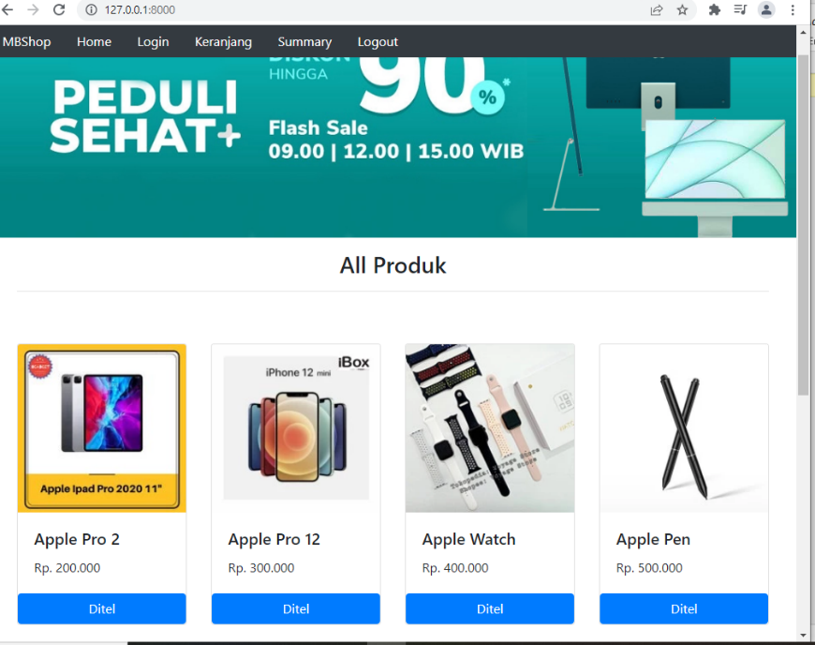

1. Ditel produk

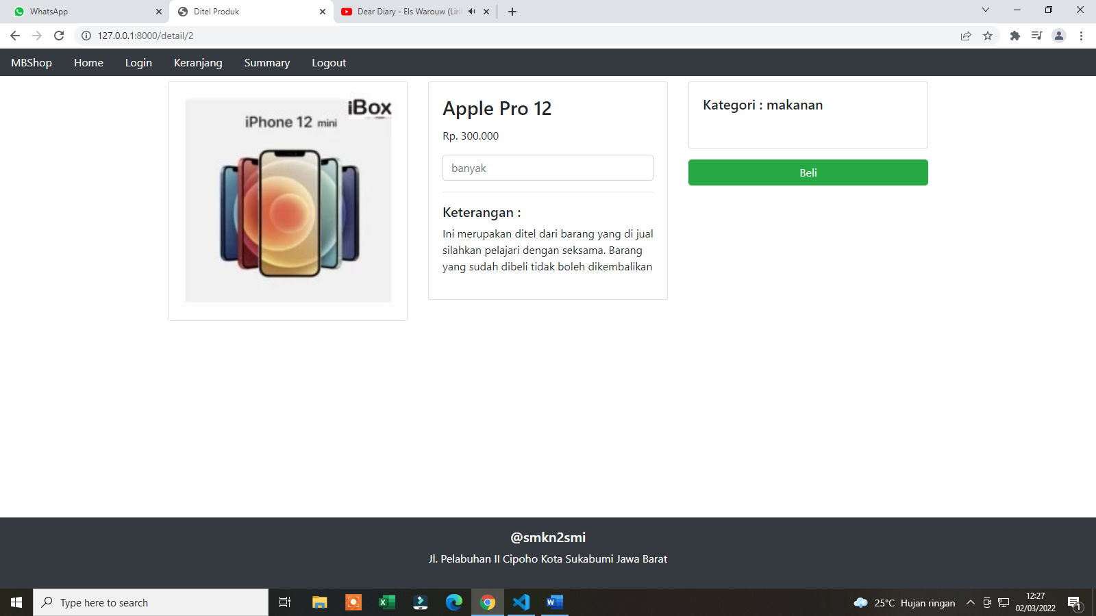

1. Login

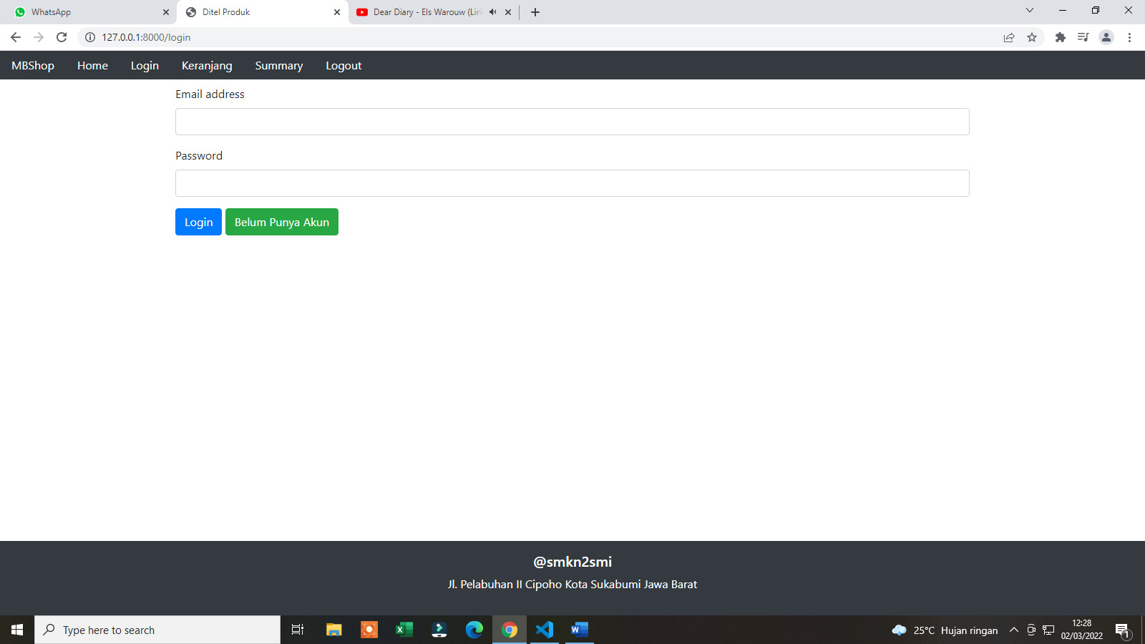

1. Registrasi

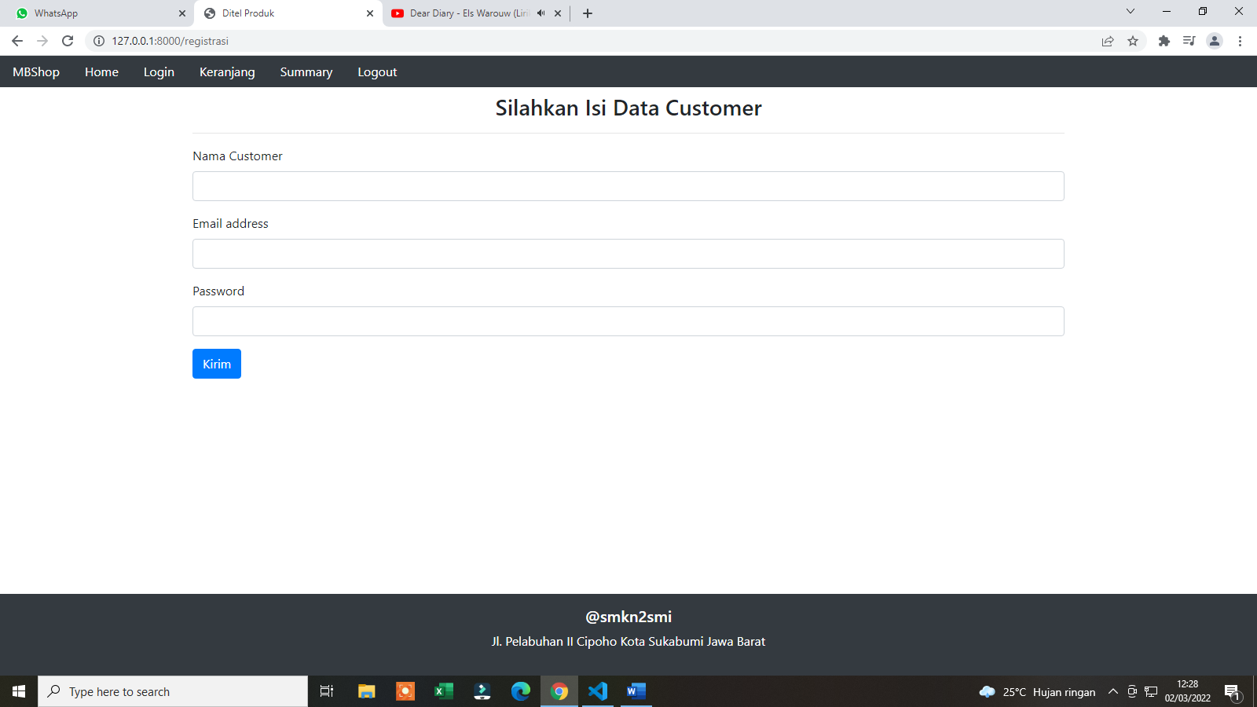

1. keranjang

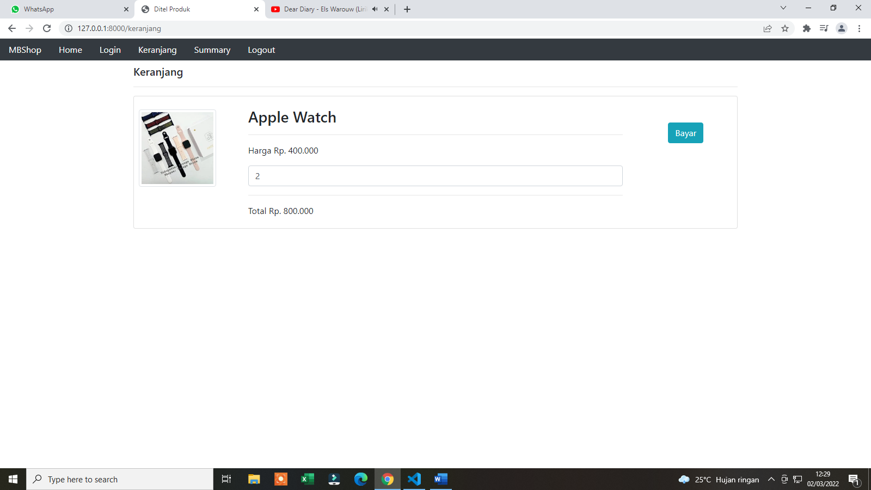

1. checkout/upload bukti bayar

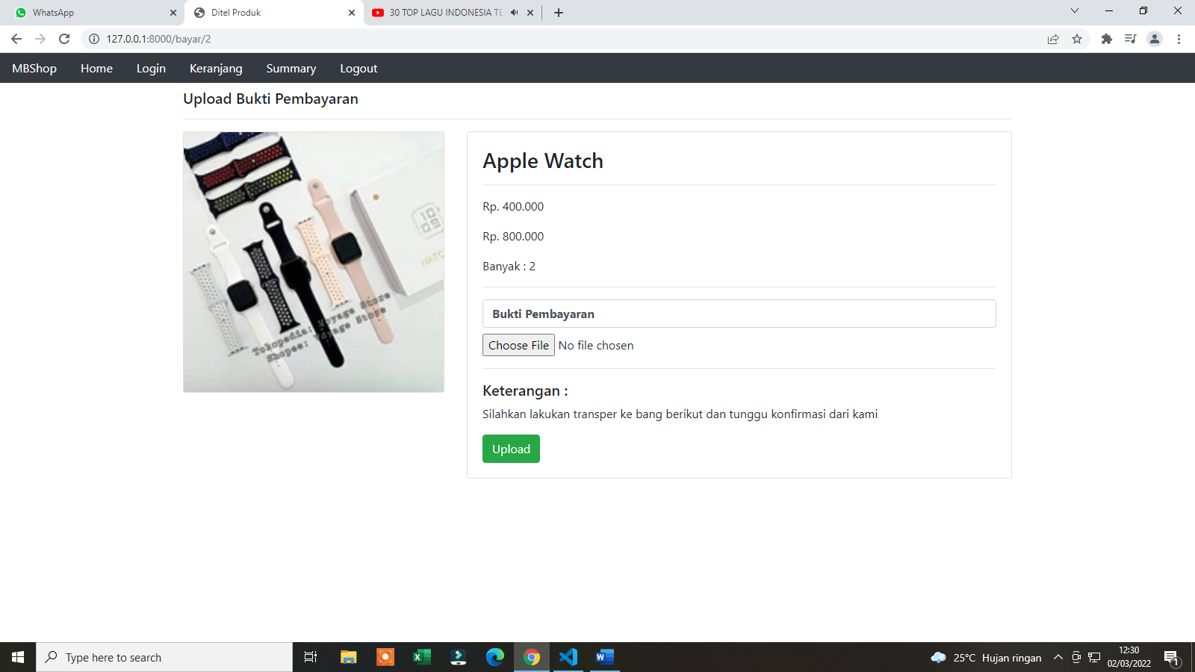

1. summary

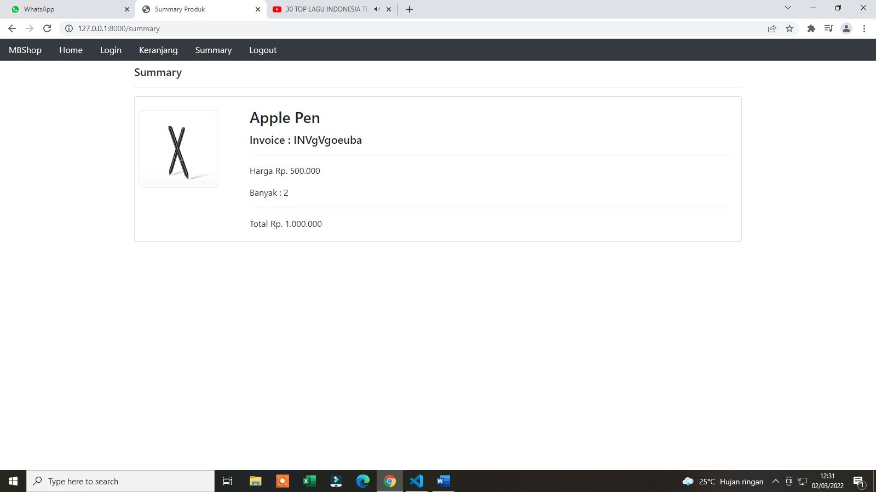

**DAFTAR CHECKLIST TEMPLATE**

|  |  |  |  |  |  |  |  |  |
| --- | --- | --- | --- | --- | --- | --- | --- | --- |
| No | Nama | Home | Ditel | Login | Registr | Keranj | Checko | Summary |
| 1 | Abdullah |  |  |  |  |  |  |  |
| 2 | Adella Puspita |  |  |  |  |  |  |  |
| 3 | Alisa Muti Sugianti |  |  |  |  |  |  |  |
| 4 | Amalia Nur Fauzianti |  |  |  |  |  |  |  |
| 5 | Desti Indriani |  |  |  |  |  |  |  |
| 6 | Dewa Putra Pratama |  |  |  |  |  |  |  |
| 7 | Dimas Nur Ilham |  |  |  |  |  |  |  |
| 8 | E. Clara Rabila Tsani |  |  |  |  |  |  |  |
| 9 | Erica Puspita Salamah |  |  |  |  |  |  |  |
| 10 | Faris Muhammad Ramdan |  |  |  |  |  |  |  |
| 11 | Hafiz Arbi |  |  |  |  |  |  |  |
| 12 | Hafizh Arsyi Alamsyah |  |  |  |  |  |  |  |
| 13 | Haris Farida Abdul Nurwahid |  |  |  |  |  |  |  |
| 14 | Moch Hapi Barkah |  |  |  |  |  |  |  |
| 15 | Mochamad Iqbal Fadila |  |  |  |  |  |  |  |
| 16 | Mochammad Fitra Ilyas |  |  |  |  |  |  |  |
| 17 | Moh. Ariel Firdaus Hasan |  |  |  |  |  |  |  |
| 18 | Muhamad Alfathin Izharuddin |  |  |  |  |  |  |  |
| 19 | Muhammad Hafidz Fauzan |  |  |  |  |  |  |  |
| 20 | Muhammad Bhima Augusta |  |  |  |  |  |  |  |
| 21 | Muhammad Imran Khairul |  |  |  |  |  |  |  |
| 22 | Muhammad Jawahiruzzaman |  |  |  |  |  |  |  |
| 23 | Muhammad Reva Pratama |  |  |  |  |  |  |  |
| 24 | Nurul Oktaviani |  |  |  |  |  |  |  |
| 25 | Rachmatu Zabila |  |  |  |  |  |  |  |
| 26 | Rafi Peramudiva Ramadhan |  |  |  |  |  |  |  |
| 27 | Raihan Rahadian Syach |  |  |  |  |  |  |  |
| 28 | Razwa Sakha Pradipa |  |  |  |  |  |  |  |
| 29 | Renaldi Pasya Darmansyah |  |  |  |  |  |  |  |
| 30 | Ryan Sahk Suhada |  |  |  |  |  |  |  |
| 31 | Sabrina Auliya Andini |  |  |  |  |  |  |  |
| 32 | Satria Sangga Buana |  |  |  |  |  |  |  |
| 33 | Shunnia Nur Ainahaq |  |  |  |  |  |  |  |
| 34 | Tazkia Inti Sapara |  |  |  |  |  |  |  |
| 35 | Zane Syakila |  |  |  |  |  |  |  |

**DAFTAR CHECKLIST DATABASE DLL**

|  |  |  |  |  |  |
| --- | --- | --- | --- | --- | --- |
| No | Nama | DB & Env | Model & migr | Isi migrat | Eloq model |
| 1 | Abdullah |  |  |  |  |
| 2 | Adella Puspita |  |  |  |  |
| 3 | Alisa Muti Sugianti |  |  |  |  |
| 4 | Amalia Nur Fauzianti |  |  |  |  |
| 5 | Desti Indriani |  |  |  |  |
| 6 | Dewa Putra Pratama |  |  |  |  |
| 7 | Dimas Nur Ilham |  |  |  |  |
| 8 | E. Clara Rabila Tsani |  |  |  |  |
| 9 | Erica Puspita Salamah |  |  |  |  |
| 10 | Faris Muhammad Ramdan |  |  |  |  |
| 11 | Hafiz Arbi |  |  |  |  |
| 12 | Hafizh Arsyi Alamsyah |  |  |  |  |
| 13 | Haris Farida Abdul Nurwahid |  |  |  |  |
| 14 | Moch Hapi Barkah |  |  |  |  |
| 15 | Mochamad Iqbal Fadila |  |  |  |  |
| 16 | Mochammad Fitra Ilyas |  |  |  |  |
| 17 | Moh. Ariel Firdaus Hasan |  |  |  |  |
| 18 | Muhamad Alfathin Izharuddin |  |  |  |  |
| 19 | Muhammad Hafidz Fauzan |  |  |  |  |
| 20 | Muhammad Bhima Augusta |  |  |  |  |
| 21 | Muhammad Imran Khairul |  |  |  |  |
| 22 | Muhammad Jawahiruzzaman |  |  |  |  |
| 23 | Muhammad Reva Pratama |  |  |  |  |
| 24 | Nurul Oktaviani |  |  |  |  |
| 25 | Rachmatu Zabila |  |  |  |  |
| 26 | Rafi Peramudiva Ramadhan |  |  |  |  |
| 27 | Raihan Rahadian Syach |  |  |  |  |
| 28 | Razwa Sakha Pradipa |  |  |  |  |
| 29 | Renaldi Pasya Darmansyah |  |  |  |  |
| 30 | Ryan Sahk Suhada |  |  |  |  |
| 31 | Sabrina Auliya Andini |  |  |  |  |
| 32 | Satria Sangga Buana |  |  |  |  |
| 33 | Shunnia Nur Ainahaq |  |  |  |  |
| 34 | Tazkia Inti Sapara |  |  |  |  |
| 35 | Zane Syakila |  |  |  |  |

**DAFTAR CHECKLIST SYSTEM**

|  |  |  |  |  |  |  |  |  |
| --- | --- | --- | --- | --- | --- | --- | --- | --- |
| No | Nama | Fungsi Home | Fungsi Ditel | Login | Fungsi Registr | Fungsi Keranj | Fungsi Checko | Fungsi Summary |
| 1 | Abdullah |  |  |  |  |  |  |  |
| 2 | Adella Puspita |  |  |  |  |  |  |  |
| 3 | Alisa Muti Sugianti |  |  |  |  |  |  |  |
| 4 | Amalia Nur Fauzianti |  |  |  |  |  |  |  |
| 5 | Desti Indriani |  |  |  |  |  |  |  |
| 6 | Dewa Putra Pratama |  |  |  |  |  |  |  |
| 7 | Dimas Nur Ilham |  |  |  |  |  |  |  |
| 8 | E. Clara Rabila Tsani |  |  |  |  |  |  |  |
| 9 | Erica Puspita Salamah |  |  |  |  |  |  |  |
| 10 | Faris Muhammad Ramdan |  |  |  |  |  |  |  |
| 11 | Hafiz Arbi |  |  |  |  |  |  |  |
| 12 | Hafizh Arsyi Alamsyah |  |  |  |  |  |  |  |
| 13 | Haris Farida Abdul Nurwahid |  |  |  |  |  |  |  |
| 14 | Moch Hapi Barkah |  |  |  |  |  |  |  |
| 15 | Mochamad Iqbal Fadila |  |  |  |  |  |  |  |
| 16 | Mochammad Fitra Ilyas |  |  |  |  |  |  |  |
| 17 | Moh. Ariel Firdaus Hasan |  |  |  |  |  |  |  |
| 18 | Muhamad Alfathin Izharuddin |  |  |  |  |  |  |  |
| 19 | Muhammad Hafidz Fauzan |  |  |  |  |  |  |  |
| 20 | Muhammad Bhima Augusta |  |  |  |  |  |  |  |
| 21 | Muhammad Imran Khairul |  |  |  |  |  |  |  |
| 22 | Muhammad Jawahiruzzaman |  |  |  |  |  |  |  |
| 23 | Muhammad Reva Pratama |  |  |  |  |  |  |  |
| 24 | Nurul Oktaviani |  |  |  |  |  |  |  |
| 25 | Rachmatu Zabila |  |  |  |  |  |  |  |
| 26 | Rafi Peramudiva Ramadhan |  |  |  |  |  |  |  |
| 27 | Raihan Rahadian Syach |  |  |  |  |  |  |  |
| 28 | Razwa Sakha Pradipa |  |  |  |  |  |  |  |
| 29 | Renaldi Pasya Darmansyah |  |  |  |  |  |  |  |
| 30 | Ryan Sahk Suhada |  |  |  |  |  |  |  |
| 31 | Sabrina Auliya Andini |  |  |  |  |  |  |  |
| 32 | Satria Sangga Buana |  |  |  |  |  |  |  |
| 33 | Shunnia Nur Ainahaq |  |  |  |  |  |  |  |
| 34 | Tazkia Inti Sapara |  |  |  |  |  |  |  |
| 35 | Zane Syakila |  |  |  |  |  |  |  |

**DAFTAR CHECKLIST DATABASE DLL**

|  |  |  |  |  |  |
| --- | --- | --- | --- | --- | --- |
| No | Nama | DB & Env | Model & migr | Isi migrat | Eloq model |
| 1 | Abdul Hasbi |  |  |  |  |
| 2 | Adryan Ashiddiq |  |  |  |  |
| 3 | Akbar Hasan Ibrahim |  |  |  |  |
| 4 | Andina Renita Zahara |  |  |  |  |
| 5 | Andrew Maulana |  |  |  |  |
| 6 | Armansyah Maulana |  |  |  |  |
| 7 | Cahya Syaepul Alam |  |  |  |  |
| 8 | Candra Egi Saputra |  |  |  |  |
| 9 | Fani Nurlela |  |  |  |  |
| 10 | Fanny Ratna Suciati |  |  |  |  |
| 11 | Farhan DelBert Maresjembun |  |  |  |  |
| 12 | Fazril Imam Maulana |  |  |  |  |
| 13 | Febriyanti Maharani Dewi |  |  |  |  |
| 14 | Firdaus Cahya Agustian |  |  |  |  |
| 15 | Haryana |  |  |  |  |
| 16 | Hilmi Abdul Muhaimin |  |  |  |  |
| 17 | Irfan Ramadhan |  |  |  |  |
| 18 | Lusi Agustin |  |  |  |  |
| 19 | Moch Akmal Al-Razzi |  |  |  |  |
| 20 | Mochammad Syahrul |  |  |  |  |
| 21 | Muhamad Jikril Aryanda |  |  |  |  |
| 22 | Muhamad Rifda Firdaus. S |  |  |  |  |
| 23 | Nafilah Nawir Afwa |  |  |  |  |
| 24 | Naluri Insan Kamalia |  |  |  |  |
| 25 | Nandra Ramira AR |  |  |  |  |
| 26 | Neng Ripka |  |  |  |  |
| 27 | Neng Vina Ananda |  |  |  |  |
| 28 | Rifky Maulana Putra |  |  |  |  |
| 29 | Risdi Amelia |  |  |  |  |
| 30 | Rizki Rahmatullah |  |  |  |  |
| 31 | Rizky Nugraha Putra |  |  |  |  |
| 32 | Siti Mariam |  |  |  |  |
| 33 | Siti Nurlatifah |  |  |  |  |
| 34 | Yasmina Putri Salsabila |  |  |  |  |
| 35 | Zahra Putri Calisa |  |  |  |  |

**DAFTAR CHECKLIST SYSTEM**

|  |  |  |  |  |  |  |  |  |
| --- | --- | --- | --- | --- | --- | --- | --- | --- |
| No | Nama | Fungsi Home | Fungsi Ditel | Fungsi Login | Fungsi Registr | Fungsi Keranj | Fungsi Checko | Fungsi Summary |
| 1 | Abdul Hasbi |  |  |  |  |  |  |  |
| 2 | Adryan Ashiddiq |  |  |  |  |  |  |  |
| 3 | Akbar Hasan Ibrahim |  |  |  |  |  |  |  |
| 4 | Andina Renita Zahara |  |  |  |  |  |  |  |
| 5 | Andrew Maulana |  |  |  |  |  |  |  |
| 6 | Armansyah Maulana |  |  |  |  |  |  |  |
| 7 | Cahya Syaepul Alam |  |  |  |  |  |  |  |
| 8 | Candra Egi Saputra |  |  |  |  |  |  |  |
| 9 | Fani Nurlela |  |  |  |  |  |  |  |
| 10 | Fanny Ratna Suciati |  |  |  |  |  |  |  |
| 11 | Farhan DelBert Maresjembun |  |  |  |  |  |  |  |
| 12 | Fazril Imam Maulana |  |  |  |  |  |  |  |
| 13 | Febriyanti Maharani Dewi |  |  |  |  |  |  |  |
| 14 | Firdaus Cahya Agustian |  |  |  |  |  |  |  |
| 15 | Haryana |  |  |  |  |  |  |  |
| 16 | Hilmi Abdul Muhaimin |  |  |  |  |  |  |  |
| 17 | Irfan Ramadhan |  |  |  |  |  |  |  |
| 18 | Lusi Agustin |  |  |  |  |  |  |  |
| 19 | Moch Akmal Al-Razzi |  |  |  |  |  |  |  |
| 20 | Mochammad Syahrul |  |  |  |  |  |  |  |
| 21 | Muhamad Jikril Aryanda |  |  |  |  |  |  |  |
| 22 | Muhamad Rifda Firdaus. S |  |  |  |  |  |  |  |
| 23 | Nafilah Nawir Afwa |  |  |  |  |  |  |  |
| 24 | Naluri Insan Kamalia |  |  |  |  |  |  |  |
| 25 | Nandra Ramira AR |  |  |  |  |  |  |  |
| 26 | Neng Ripka |  |  |  |  |  |  |  |
| 27 | Neng Vina Ananda |  |  |  |  |  |  |  |
| 28 | Rifky Maulana Putra |  |  |  |  |  |  |  |
| 29 | Risdi Amelia |  |  |  |  |  |  |  |
| 30 | Rizki Rahmatullah |  |  |  |  |  |  |  |
| 31 | Rizky Nugraha Putra |  |  |  |  |  |  |  |
| 32 | Siti Mariam |  |  |  |  |  |  |  |
| 33 | Siti Nurlatifah |  |  |  |  |  |  |  |
| 34 | Yasmina Putri Salsabila |  |  |  |  |  |  |  |
| 35 | Zahra Putri Calisa |  |  |  |  |  |  |  |

**DAFTAR CHECKLIST TEMPLATE**

|  |  |  |  |  |  |  |  |  |
| --- | --- | --- | --- | --- | --- | --- | --- | --- |
| No | Nama | Home | Ditel | Login | Registr | Keranj | Checko | Summary |
| 1 | Abdul Hasbi |  |  |  |  |  |  |  |
| 2 | Adryan Ashiddiq |  |  |  |  |  |  |  |
| 3 | Akbar Hasan Ibrahim |  |  |  |  |  |  |  |
| 4 | Andina Renita Zahara |  |  |  |  |  |  |  |
| 5 | Andrew Maulana |  |  |  |  |  |  |  |
| 6 | Armansyah Maulana |  |  |  |  |  |  |  |
| 7 | Cahya Syaepul Alam |  |  |  |  |  |  |  |
| 8 | Candra Egi Saputra |  |  |  |  |  |  |  |
| 9 | Fani Nurlela |  |  |  |  |  |  |  |
| 10 | Fanny Ratna Suciati |  |  |  |  |  |  |  |
| 11 | Farhan DelBert Maresjembun |  |  |  |  |  |  |  |
| 12 | Fazril Imam Maulana |  |  |  |  |  |  |  |
| 13 | Febriyanti Maharani Dewi |  |  |  |  |  |  |  |
| 14 | Firdaus Cahya Agustian |  |  |  |  |  |  |  |
| 15 | Haryana |  |  |  |  |  |  |  |
| 16 | Hilmi Abdul Muhaimin |  |  |  |  |  |  |  |
| 17 | Irfan Ramadhan |  |  |  |  |  |  |  |
| 18 | Lusi Agustin |  |  |  |  |  |  |  |
| 19 | Moch Akmal Al-Razzi |  |  |  |  |  |  |  |
| 20 | Mochammad Syahrul |  |  |  |  |  |  |  |
| 21 | Muhamad Jikril Aryanda |  |  |  |  |  |  |  |
| 22 | Muhamad Rifda Firdaus. S |  |  |  |  |  |  |  |
| 23 | Nafilah Nawir Afwa |  |  |  |  |  |  |  |
| 24 | Naluri Insan Kamalia |  |  |  |  |  |  |  |
| 25 | Nandra Ramira AR |  |  |  |  |  |  |  |
| 26 | Neng Ripka |  |  |  |  |  |  |  |
| 27 | Neng Vina Ananda |  |  |  |  |  |  |  |
| 28 | Rifky Maulana Putra |  |  |  |  |  |  |  |
| 29 | Risdi Amelia |  |  |  |  |  |  |  |
| 30 | Rizki Rahmatullah |  |  |  |  |  |  |  |
| 31 | Rizky Nugraha Putra |  |  |  |  |  |  |  |
| 32 | Siti Mariam |  |  |  |  |  |  |  |
| 33 | Siti Nurlatifah |  |  |  |  |  |  |  |
| 34 | Yasmina Putri Salsabila |  |  |  |  |  |  |  |
| 35 | Zahra Putri Calisa |  |  |  |  |  |  |  |